Week 1 Assignment 3

Question 1 [1]

To Count File Extensions and Group it using LINQ

using System;

using System.Collections.Generic;

using System.Linq;

using System.Text;

using System.Threading.Tasks;

using System.IO;

namespace Week1_Assignment3_partb

{

class Program

{

static void Main(string[] args)

{

string[] filePaths = Directory.GetFiles(@"D:\");

string[] allfile=new string[filePaths.Length];

int i = 0;

foreach(string myfile in filePaths)

{

allfile[i++] = Path.GetFileName(myfile);

}

var mygroup = allfile.Select(file => Path.GetExtension(file).TrimStart('.').ToLower())

.GroupBy(x => x,(ext, extCnt) =>new

{

Extension = ext,

Count = extCnt.Count()

});

Console.WriteLine(@"D:\");

foreach (var type in mygroup)

Console.WriteLine(" There are {0} Files with {1} Extension in this directory",type.Count, type.Extension);

Console.ReadLine();

}

}

}

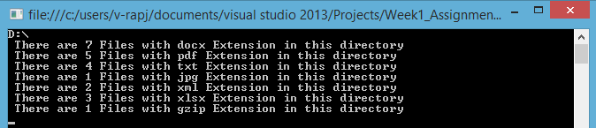

Question 1 [2]

To Calculate Size of File using LINQ

using System;

using System.Collections.Generic;

using System.IO;

using System.Linq;

using System.Text;

using System.Threading.Tasks;

namespace Week1_Assignment3_partb

{

class Class1

{

static void Main(string[] args)

{

DirectoryInfo dirinfo = new DirectoryInfo(@"D:\");

var fileQuery =from FileInfo fileinfo in dirinfo.GetFiles()

orderby fileinfo.Length descending

select new { fileinfo.Length, fileinfo.Name };

foreach (var sizes in fileQuery)

{

Console.WriteLine("size : {1,10} bytes for the file : {0}",sizes.Name,sizes.Length);

}

Console.ReadKey();

}

}

}

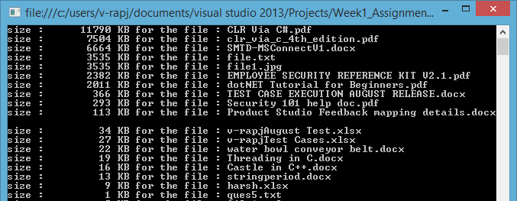

Question 1 [3]

To Generate Odd Numbers in Parallel using LINQ

using System;

using System.Collections.Generic;

using System.Linq;

using System.Text;

using System.Threading.Tasks;

namespace Week1_Assignment3_partb

{

class OddNumberParallel

{

static void Main(string[] args)

{

IEnumerable<int> oddNums = ((ParallelQuery<int>)ParallelEnumerable.Range(1,10))

.Where(x => x % 2 != 0)

.Select(i => i);

foreach (int each in oddNums)

Console.WriteLine("{0,10}",each);

Console.ReadLine();

}

}

}

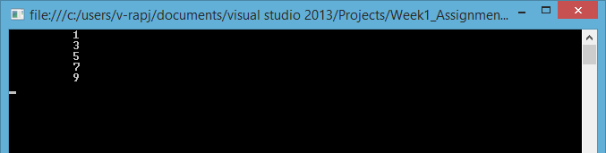

Question 1 [4]

using System;

using System.Collections;

using System.Collections.Generic;

using System.Linq;

using System.Text;

using System.Threading.Tasks;

namespace Week1_Assignment3_partb

{

class EnumerableInterface

{

public static void Main()

{

IEnumerable list = new List<string> { "Raj", "Rahul" , "Mani", "Bala"};

IEnumerable<string> result =from string item in list

select item;

foreach (string str in result)

{

Console.WriteLine(str);

}

Console.ReadLine();

}

}

}

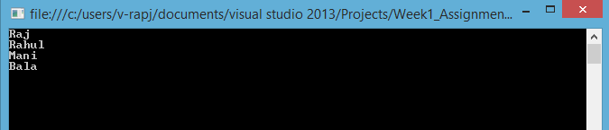

Question 1 [5]

To Divide Sequence into Groups using LINQ

using System;

using System.Collections.Generic;

using System.Linq;

using System.Text;

using System.Threading.Tasks;

namespace Week1_Assignment3_partb

{

class SequeceGroup

{

public static void Main()

{

var sequence = Enumerable.Range(100, 100).Select(x => x / 10f);

var groups = from ele in sequence.Select((first, second) => new { first, tens=second/10 })

group ele.first by ele.tens into set

select new { Min = set.Min(), Max = set.Max() };

foreach (var grp in groups)

Console.WriteLine("Min: {0} Max: {1} " , grp.Min, grp.Max);

Console.ReadKey();

}

}

}

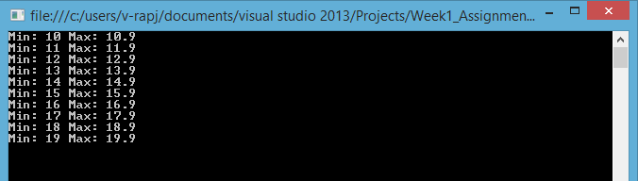

Question 1 [6]

To Display the Student Details using Select Clause LINQ

Create student class & populate the data into StudentList.

using System;

using System.Collections.Generic;

using System.Linq;

using System.Text;

using System.Threading.Tasks;

namespace Week1_Assignment3_partb

{

class Student

{

public class collect

{

public string studentName{get;set;}

public string studentClass {get;set; }

public string studentNo { get; set; }

}

List<collect> mystudents=new List<collect>();

public void fetch()

{

Console.WriteLine("Enter the student details:");

string name = Console.ReadLine();

string rollno = Console.ReadLine();

string hisclass = Console.ReadLine();

mystudents.Add(new collect { studentName = name, studentNo = rollno, studentClass = hisclass });

}

public void print(Student myobj)

{

IEnumerable<collect> queryStudent = from student in myobj.mystudents

select student;

foreach(var query in queryStudent)

{

Console.WriteLine("{1} with roll number {2} is in {0} class", query.studentClass, query.studentName, query.studentNo);

}

}

public static void Main()

{

Student listgenerate=new Student();

listgenerate.fetch();

listgenerate.fetch();

listgenerate.print(listgenerate);

Console.ReadKey();

}

}

}

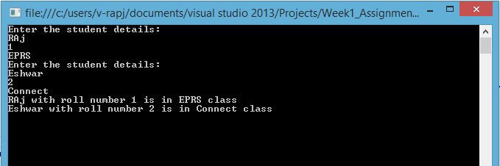

Question 1 [7]

To Display the Greatest numbers in an Array using WHERE Clause LINQ

using System;

using System.Collections.Generic;

using System.Linq;

using System.Text;

using System.Threading.Tasks;

namespace Week1_Assignment3_partb

{

class GreatestinArray

{

static public int[] mynums;

static void fetch()

{

Console.WriteLine("Entr the number of inputs");

int size = Convert.ToInt32(Console.ReadLine());

mynums = new int[size];

Console.WriteLine("Enter {0} numbers", size);

for (int i = 0; i < size; i++)

{

mynums[i] = Convert.ToInt32(Console.ReadLine());

}

}

static void print()

{

var greatest = from num in mynums

where num > mynums[0]

select num;

Console.WriteLine("Numbers greater than {0} are:",mynums[0]);

foreach (var groups in greatest)

{

Console.Write("{0,10}",groups);

}

}

public static void Main()

{

fetch();

print();

Console.ReadKey();

}

}

}

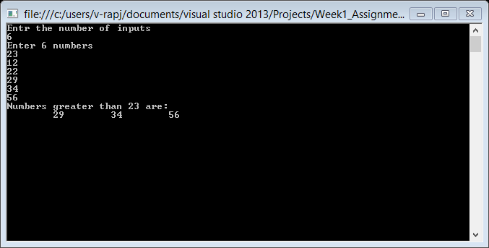

Question 1 [8]

To Display the Smallest numbers in a List Collection using FROM Clause LINQ

using System;

using System.Collections.Generic;

using System.Linq;

using System.Text;

using System.Threading.Tasks;

namespace Week1_Assignment3_partb

{

class smallestnum

{

public static List<int> mynum = new List<int>();

public static void Main()

{

Console.WriteLine("Enter the number of elements to be inputted");

int counts = Convert.ToInt32(Console.ReadLine());

Console.WriteLine("Enter {0} mynum",counts);

for (int i = 0; i < counts; i++)

{

int num = Convert.ToInt32(Console.ReadLine());

mynum.Add(num);

}

var smaller = from min in mynum

where min< mynum[0]

select min;

Console.WriteLine("mynumbers smaller than {0} are:",mynum[0]);

foreach (int num in smaller)

{

Console.WriteLine(num);

}

Console.ReadKey();

}

}

}

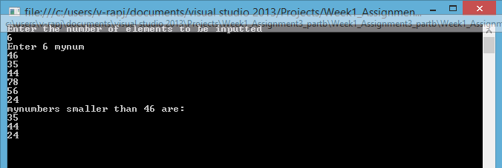

Question 1 [9]

To Implement Let Condition using LINQ

using System;

using System.Collections.Generic;

using System.Linq;

using System.Text;

using System.Threading.Tasks;

namespace Week1_Assignment3_partb

{

class LetLINQ

{

class myclass

{

public int studentID;

public string studentName;

public int mark;

}

static void Main(string[] args)

{

List<myclass> mylet = new List<myclass>

{

new myclass{ studentID=1,studentName="Raj",mark=66},

new myclass{ studentID=2,studentName="Bala",mark=96},

new myclass{ studentID=3,studentName="Guru",mark=70},

new myclass{ studentID=4,studentName="Mani",mark=90},

};

var aboveAvg = from student in mylet

let totalmark = mylet.Sum(x => x.mark)

let avgMark = totalmark / mylet.Count

where avgMark > student.mark

select student;

foreach (var student in aboveAvg)

{

Console.WriteLine("{0} with ID:{1} has the mark of {2} which is below average ", student.studentName,student.studentID,student.mark);

}

Console.ReadKey();

}

}

}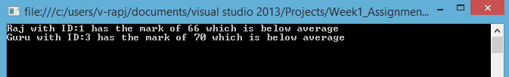

Question 2 : Write C# programs to illustrate ADO.NET

[1] To read data from data Reader (from SQL Query)

using System;

using System.Collections.Generic;

using System.Data.SqlClient;

using System.Linq;

using System.Text;

using System.Threading.Tasks;

using System.Data;

namespace Week1_Assignment3_partb

{

class DataReader

{

SqlConnection con;

SqlCommand cmd;

public void openConn()

{

con = new SqlConnection("Data Source=D-113036399\\SQLEXPRESS;Initial Catalog=mydbo;Integrated Security=True");

con.Open();

}

public void giveCommand()

{

cmd= new SqlCommand();

cmd.CommandType= CommandType.StoredProcedure;

cmd.CommandText="sp_selectall";

cmd.Connection=con;

}

public void execteReader()

{

SqlDataReader myreader = cmd.ExecuteReader();

while (myreader.Read())

{

decimal stuid = myreader.GetDecimal(0);

string stuname = myreader.GetString(1);

Console.WriteLine("Student with ID {0} has the Name {1}", stuid, stuname);

}

}

public void close()

{

con.Close();

Console.ReadKey();

}

public static void Main()

{

DataReader mydata=new DataReader();

mydata.openConn();

mydata.giveCommand();

mydata.execteReader();

mydata.close();

}

}

}

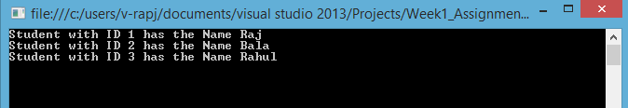

Question 2 [2]

To execute a stored procedure to insert record in database

using System;

using System.Collections.Generic;

using System.Data;

using System.Data.SqlClient;

using System.Linq;

using System.Text;

using System.Threading.Tasks;

using System.Data.SqlClient;

namespace Week1_Assignment3_partb

{

class spInsert

{

SqlConnection con;

SqlCommand cmd;

decimal ID;

string Name;

public void openConn()

{

con = new SqlConnection("Data Source=D-113036399\\SQLEXPRESS;Initial Catalog=mydbo;Integrated Security=True");

con.Open();

}

public void giveCommand(decimal ID,string Name)

{

cmd = new SqlCommand();

cmd.CommandType = CommandType.StoredProcedure;

cmd.CommandText = "sp_insertone";

cmd.Connection = con;

cmd.Parameters.AddWithValue("@id",ID);

cmd.Parameters.AddWithValue("@name",Name);

if(cmd.ExecuteNonQuery()!=0)

{

Console.WriteLine("Value Entered into the Table Successfully");

}

}

public void close()

{

con.Close();

Console.ReadKey();

}

public static void Main()

{

Console.WriteLine("Enter the ID and NAME to be saved to database");

spInsert myobj = new spInsert();

myobj.ID = Convert.ToInt32(Console.ReadLine());

myobj.Name = Console.ReadLine();

myobj.openConn();

myobj.giveCommand(myobj.ID, myobj.Name);

myobj.close();

Console.ReadLine();

}

}

}

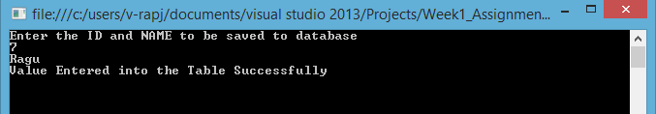

Question 2 [3]

To read the multiple result sets from a stored procedure

using System;

using System.Collections.Generic;

using System.Data;

using System.Data.SqlClient;

using System.Linq;

using System.Text;

using System.Threading.Tasks;

using System.Data.SqlClient;

namespace Week1_Assignment3_partb

{

class spSelectfrom2

{

SqlConnection con;

SqlCommand cmd;

public void openConn()

{

con = new SqlConnection("Data Source=D-113036399\\SQLEXPRESS;Initial Catalog=mydbo;Integrated Security=True");

con.Open();

}

public void giveCommand()

{

cmd = new SqlCommand();

cmd.CommandType = CommandType.StoredProcedure;

cmd.CommandText = "sp_selectfrom2";

cmd.Connection = con;

}

public void multipleTable()

{

SqlDataAdapter adapter = new SqlDataAdapter(cmd);

DataSet ds = new DataSet();

adapter.Fill(ds);

DataTable tableA = ds.Tables[0];

DataTable tableB = ds.Tables[1];

DataTable tableC = ds.Tables[2];

foreach (DataRow row in tableA.Rows)

{

Console.WriteLine();

for (int x = 0; x < tableA.Columns.Count; x++)

{

Console.Write(row[x].ToString() + " ");

}

}

foreach (DataRow row in tableB.Rows)

{

Console.WriteLine();

for (int x = 0; x < tableB.Columns.Count; x++)

{

Console.Write(row[x].ToString() + " ");

}

}

foreach (DataRow row in tableC.Rows)

{

Console.WriteLine();

for (int x = 0; x < tableC.Columns.Count; x++)

{

Console.Write(row[x].ToString() + " ");

}

}

}

public void close()

{

con.Close();

Console.ReadKey();

}

public static void Main()

{

spSelectfrom2 mydata = new spSelectfrom2();

mydata.openConn();

mydata.giveCommand();

mydata.multipleTable();

mydata.close();

}

}

}

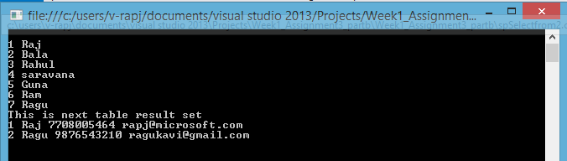

Question 2 [4]

To read scalar values from SQL Command

using System;

using System.Collections.Generic;

using System.Data;

using System.Data.SqlClient;

using System.Linq;

using System.Text;

using System.Threading.Tasks;

namespace Week1_Assignment3_partb

{

class ScalarReturn

{

SqlConnection con;

SqlCommand cmd;

decimal ID;

string Name;

public void openConn()

{

con = new SqlConnection("Data Source=D-113036399\\SQLEXPRESS;Initial Catalog=mydbo;Integrated Security=True");

con.Open();

}

public void giveCommand(decimal ID)

{

cmd = new SqlCommand();

cmd.CommandType = CommandType.StoredProcedure;

cmd.CommandText = "sp_selectbyID";

cmd.Connection = con;

cmd.Parameters.AddWithValue("@id", ID);

}

public void execteScalar()

{

Name = (string)cmd.ExecuteScalar();

Console.WriteLine("{0} has the name {1}", ID, Name);

}

public void close()

{

con.Close();

Console.ReadKey();

}

public static void Main()

{

ScalarReturn mydata = new ScalarReturn();

mydata.openConn();

Console.WriteLine("Enter ID to get name");

mydata.ID = Convert.ToInt32(Console.ReadLine());

mydata.giveCommand(mydata.ID);

mydata.execteScalar();

mydata.close();

}

}

}

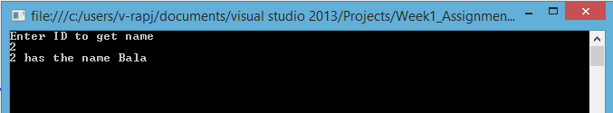

Question 2 [5]

Using Dataset & Data Adapter

using System;

using System.Collections.Generic;

using System.Data;

using System.Data.SqlClient;

using System.Linq;

using System.Text;

using System.Threading.Tasks;

namespace Week1_Assignment3_partb

{

class spSelectfrom2

{

SqlConnection con;

SqlCommand cmd;

public void openConn()

{

con = new SqlConnection("Data Source=D-113036399\\SQLEXPRESS;Initial Catalog=mydbo;Integrated Security=True");

con.Open();

}

public void giveCommand()

{

cmd = new SqlCommand();

cmd.CommandType = CommandType.StoredProcedure;

cmd.CommandText = "sp_selectfrom2";

cmd.Connection = con;

}

public void multipleTable()

{

SqlDataAdapter adapter = new SqlDataAdapter(cmd);

DataSet ds = new DataSet();

adapter.Fill(ds);

DataTable tableA = ds.Tables[0];

DataTable tableB = ds.Tables[1];

DataTable tableC = ds.Tables[2];

foreach (DataRow row in tableA.Rows)

{

Console.WriteLine();

for (int x = 0; x < tableA.Columns.Count; x++)

{

Console.Write(row[x].ToString() + " ");

}

}

foreach (DataRow row in tableB.Rows)

{

Console.WriteLine();

for (int x = 0; x < tableB.Columns.Count; x++)

{

Console.Write(row[x].ToString() + " ");

}

}

foreach (DataRow row in tableC.Rows)

{

Console.WriteLine();

for (int x = 0; x < tableC.Columns.Count; x++)

{

Console.Write(row[x].ToString() + " ");

}

}

}

public void close()

{

con.Close();

Console.ReadKey();

}

public static void Main()

{

spSelectfrom2 mydata = new spSelectfrom2();

mydata.openConn();

mydata.giveCommand();

mydata.multipleTable();

mydata.close();

}

}

}



Question 3 [1]

Code-first Approach

using System;

using System.Collections.Generic;

using System.ComponentModel.DataAnnotations;

using System.ComponentModel.DataAnnotations.Schema;

using System.Data.Entity;

using System.Linq;

using System.Text;

using System.Threading.Tasks;

namespace Week1_Assignment3_partb

{

class codefirst

{

[Table("EmployeeInfo")]

public class Employee

{

[Key]

public int EmployeeID { get; set; }

[Required]

public string EmployeeName { get; set; }

public int DeptartmentId { get; set; }

[ForeignKey("DeptartmentId")]

public virtual Deptartment Deptartment { get; set; }

}

[Table("DeptartmentInfo")]

public class Deptartment

{

[Key]

public int DeptartmentId { get; set; }

[Required]

public string DeptartmentName { get; set; }

public virtual ICollection<Employee> Employees { get; set; }

}

public class myContext : DbContext

{

public myContext() : base("EmpdataDBO") { }

public DbSet<Employee> Employees { get; set; }

public DbSet<Deptartment> Deptartments { get; set; }

}

static void Main()

{

using (var context = new myContext())

{

Deptartment mydept = new Deptartment() { DeptartmentId=12,DeptartmentName="IT" };

context.Deptartments.Add(mydept);

Employee newjoin = new Employee() { EmployeeName = "Mani" ,EmployeeID=2};

newjoin.DeptartmentId = 1;

context.Employees.Add(newjoin);

context.SaveChanges();

}

}

}

}

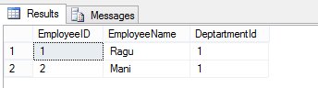

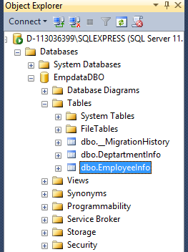

Question 3 [2]

Database-first Approach

CONTEXT:

//------------------------------------------------------------------------------

// <auto-generated>

// This code was generated from a template.

//

// Manual changes to this file may cause unexpected behavior in your application.

// Manual changes to this file will be overwritten if the code is regenerated.

// </auto-generated>

//------------------------------------------------------------------------------

namespace ConsoleApplication1

{

using System;

using System.Data.Entity;

using System.Data.Entity.Infrastructure;

public partial class mydboEntities : DbContext

{

public mydboEntities()

: base("name=mydboEntities")

{

}

protected override void OnModelCreating(DbModelBuilder modelBuilder)

{

throw new UnintentionalCodeFirstException();

}

public virtual DbSet<TB_details> TB_details { get; set; }

public virtual DbSet<TB_EmployeeName> TB_EmployeeName { get; set; }

}

}

DETAILS TABLE:

//------------------------------------------------------------------------------

// <auto-generated>

// This code was generated from a template.

//

// Manual changes to this file may cause unexpected behavior in your application.

// Manual changes to this file will be overwritten if the code is regenerated.

// </auto-generated>

//------------------------------------------------------------------------------

namespace ConsoleApplication1

{

using System;

using System.Collections.Generic;

public partial class TB_details

{

public decimal ID { get; set; }

public string Name { get; set; }

public decimal Phonenumber { get; set; }

public string EmailID { get; set; }

}

}

EMPLOYEE TABLE:

//------------------------------------------------------------------------------

// <auto-generated>

// This code was generated from a template.

//

// Manual changes to this file may cause unexpected behavior in your application.

// Manual changes to this file will be overwritten if the code is regenerated.

// </auto-generated>

//------------------------------------------------------------------------------

namespace ConsoleApplication1

{

using System;

using System.Collections.Generic;

public partial class TB_EmployeeName

{

public decimal ID { get; set; }

public string Name { get; set; }

}

}

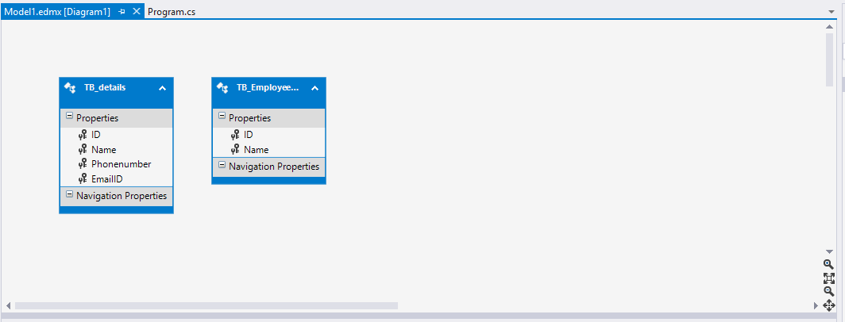

Question 4 [1]

Data Access Application Block

using Microsoft.Practices.EnterpriseLibrary.Data;

using Microsoft.Practices.EnterpriseLibrary.Data.Sql;

using System;

using System.Collections.Generic;

using System.Data;

using System.Data.Common;

using System.Linq;

using System.Text;

using System.Threading.Tasks;

namespace EnterpriseLibrary

{

class Program

{

static void Main(string[] args)

{

SqlDatabase sqlServerDB = new SqlDatabase("Data Source=D-113036399\\SQLEXPRESS;Initial Catalog=mydbo;Integrated Security=True");

DataSet productDataSet;

string sql = "SELECT * FROM TB_EmployeeName";

productDataSet = sqlServerDB.ExecuteDataSet(CommandType.Text, sql);

DbCommand cmd = sqlServerDB.GetSqlStringCommand(sql);

productDataSet = sqlServerDB.ExecuteDataSet(cmd);

DataTable dt = productDataSet.Tables[0];

foreach (DataRow row in dt.Rows)

{

Console.WriteLine();

for (int x = 0; x < dt.Columns.Count; x++)

{

Console.Write(row[x].ToString() + " ");

}

}

Console.ReadKey();

}

}

}

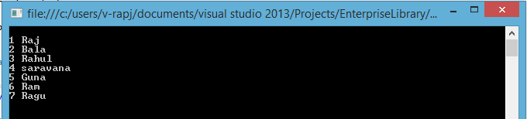

Question 5

Write C# program to do logging in event logger.

using System;

using System.Collections.Generic;

using System.IO;

using System.Linq;

using System.Text;

using System.Diagnostics;

using System.Threading.Tasks;

namespace EventLog

{

class Program

{

static void Main(string[] args)

{

try

{

StreamReader mystream = File.OpenText(@"D:\cast.txt");

mystream.ReadToEnd();

mystream.Close();

}

catch (Exception ex)

{

System.Diagnostics.EventLog mylog = new System.Diagnostics.EventLog("Application");

mylog.Source = "Application";

Console.WriteLine("Application Event Log : \n {0}", ex.Message);

mylog.WriteEntry("Reading file failed " + ex.Message, EventLogEntryType.FailureAudit);

Console.ReadKey();

}

}

}

}

